### *Transition On purpose speaking & Training TOURS*



Our mission is to provide teens and young adults with tips, tools, strategies and resources to make healthy choices, connect with their unique purpose and be the best they can be.



* Keynotes
* Workshops
* Training
* Coaching
* Consulting
* Hypnosis



*"Together, let’s see how   
many people we can impact,* [*empower*](http://www.selfgrowth.com/empower.html)*, uplift and encourage to reach their fullest potential.”  ~Anthony Robbins*

# *Students*

# *are*

# *Talking With Trisha*

Transition On Purpose

Trisha Jacobson

PO Box 207

Eaton, NH 03832

**Transition On Purpose Coaching**

**Trisha Jacobson**

**Phone (603) 452-7350**

[**trisharx@aol.com**](mailto:trisharx@aol.com)

**www.trishajacobson.com**

*The Sexuality,*

*Self-Esteem and Success Expert*

## *Teaching lessons that last a lifetime through Keynotes, Presentations, Workshops, Coaching & Consulting*



## Topics



### *Sexuality*

### *peer pressure*

### *Self-esteem and empowerment*

### *the subconscious mind & the power of positivity*

### *life purpose*

### *Success principles*

### *goal setting*

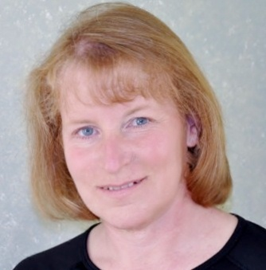

## About Trisha



In addition to delivering and facilitating hundreds of presentations and workshops to student, parent and professional audiences, Trisha is a certified hypnotherapist and coach. She uses both traditional coaching and hypnotherapy techniques with individuals and groups to access both the conscious and subconscious mind and clear the path to success.

Trisha provides individual and group training, coaching and consulting and facilitates mastermind groups around exploring purpose, creating a vision, goal setting, action plans, accountability and networking.

She has been personally trained and mentored by Jack Canfield, America’s #1 Success Coach and author of the Chicken Soup for the Soul series and The Success Principles for adults and teens.

**Trisha Jacobson**

**603-452-7350**

**trisharx@aol.com**

**www.trishajacobson.com**

## Presentations & Workshops



### *Sex ed for co-ed’s: planning in the present while preparing for your future*

### *Red Light, Yellow Light, Green Light: Navigating the STD highway*

### *success mapping: getting from where you are to where you want to be*

### *pathway to purpose: discovering your way to success while living your purpose*

### *at the waterline: Harnessing the power of the subconscious mind*

*Call 603-452-7350 today to discuss your ideas for custom workshops, presentations and coaching sessions!*

